Contoh code aplikasi dengan algoritma monte carlo

Nama : Ivan Febriansyah  
Kelas : Visioner  
Full code :

1. **The dice Game**

Our simple game will involve two six-sided dice. In order to win, the player needs to roll the same number on both dice. A six-sided die has six possible outcomes (1, 2, 3, 4, 5, and 6). With two dice, there is now 36 possible outcomes (1 and 1, 1 and 2, 1 and 3, etc., or 6 x 6 = 36 possibilities). In this game, the house has more opportunities to win (30 outcomes vs. the player’s 6 outcomes), meaning the house has the quite the advantage.

Let’s say our player starts with a balance of $1,000 and is prepared to lose it all, so they bet $1 on every roll (meaning both dice are rolled) and decide to play 1,000 rolls. Because the house is so generous, they offer to payout 4 times the player’s bet when the player wins. For example, if the player wins the first roll, their balance increases by $4, and they end the round with a balance of $1,004. If they miraculously went on a 1,000 roll win-streak, they could go home with $5,000. If they lost every round, they could go home with nothing. Not a bad risk-reward ratio… or maybe it is.

**Importing Python Packages**

Let’s simulate our game to find out if the player made the right choice to play. We start our code by importing our necessary Python packages: Pyplot from Matplotlib and random. We will be using Pyplot for visualizing our results and random to simulate a normal six-sided dice roll.

# Importing Packages  
import matplotlib.pyplot as plt  
import random

**Dice Roll Function**

Next, we can define a function that will randomize an integer from 1 to 6 for both dice (simulating a roll). The function will also compare the two dice to see if they are the same. The function will return a Boolean variable, same_num, to store if the rolls are the same or not. We will use this value later to determine actions in our code.

# Creating Roll Dice Function  
def roll_dice():  
 die_1 = random.randint(1, 6)  
 die_2 = random.randint(1, 6)  
  
 # Determining if the dice are the same number  
 if die_1 == die_2:  
 same_num = True  
 else:  
 same_num = False  
 return same_num

**Inputs and Tracking Variables**

Every Monte Carlo simulation will require you to know what your inputs are and what information you are looking to obtain. We already defined what our inputs are when we described the game. We said our number of rolls per game is 1,000, and the amount the player will be betting each roll is $1. In addition to our input variables, we need to define how many times we want to simulate the game. We can use the num_simulations variable as our Monte Carlo simulation count. The higher we make this number, the more accurate the predicted probability is to its true value.

The number of variables we can track usually scales with the complexity of a project, so nailing down what you want information on is important. For this example, we will track the win probability (wins per game divided by the total number of rolls) and ending balance for each simulation (or game). These are initialized as lists and will be updated at the end of each game.

# Inputs  
num_simulations = 10000  
max_num_rolls = 1000  
bet = 1  
  
# Tracking  
win_probability = []  
end_balance = []

**Setting up Figure**

The next step is setting up our figure before running through the simulation. By doing this prior to the simulation, it allows us to add lines to our figure after each game. Then, once we have run all of the simulations, we can display the plot to show our results.

# Creating Figure for Simulation Balances  
fig = plt.figure()  
plt.title("Monte Carlo Dice Game [" + str(num_simulations) + "   
 simulations]")  
plt.xlabel("Roll Number")  
plt.ylabel("Balance [$]")  
plt.xlim([0, max_num_rolls])

**Monte Carlo Simulation**

In the code below, we have an outer for loop that iterates through our pre-defined number of simulations (10,000 simulations) and a nested while loop that runs each game (1,000 rolls). Before we start each while loop, we initialize the player’s balance as $1,000 (as a list for plotting purposes) and a count for rolls and wins.

Our while loop will simulate the game for 1,000 rolls. Inside this loop, we roll the dice and use the Boolean variable returned from roll_dice() to determine the outcome. If the dice are the same number, we add 4 times the bet to the balance list and add a win to the win count. If the dice are different, we subtract the bet from the balance list. At the end of each roll, we add a count to our num_rolls list.

Once the number of rolls hits 1,000, we can calculate the player’s win probability as the number of wins divided by the total number of rolls. We can also store the ending balance for the completed game in the tracking variable end_balance. Finally, we can plot the num_rolls and balance variables to add a line to the figure we defined earlier.

# For loop to run for the number of simulations desired  
for i in range(num_simulations):  
 balance = [1000]  
 num_rolls = [0]  
 num_wins = 0 # Run until the player has rolled 1,000 times  
 while num_rolls[-1] < max_num_rolls:  
 same = roll_dice() # Result if the dice are the same number  
 if same:  
 balance.append(balance[-1] + 4 * bet)  
 num_wins += 1  
 # Result if the dice are different numbers  
 else:  
 balance.append(balance[-1] - bet)  
  
 num_rolls.append(num_rolls[-1] + 1)# Store tracking variables and add line to figure  
 win_probability.append(num_wins/num_rolls[-1])  
 end_balance.append(balance[-1])  
 plt.plot(num_rolls, balance)

**Obtaining Results**

The last step is displaying meaningful data from our tracking variables. We can display our figure (shown below) that we created in our for loop. Also, we can calculate and display (shown below) our overall win probability and ending balance by averaging our win_probability and end_balance lists.

# Showing the plot after the simulations are finished  
plt.show()  
  
# Averaging win probability and end balance  
overall_win_probability = sum(win_probability)/len(win_probability)  
overall_end_balance = sum(end_balance)/len(end_balance)# Displaying the averages  
print("Average win probability after " + str(num_simulations) + "   
 runs: " + str(overall_win_probability))  
print("Average ending balance after " + str(num_simulations) + "   
 runs: $" + str(overall_end_balance))

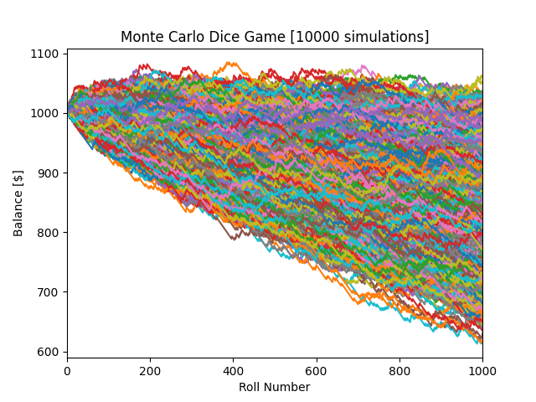

Average win probability after 10000 simulations: 0.1667325999999987  
Average ending balance after 10000 simulations: $833.663

**Analyzing Results**

The most important part of any Monte Carlo simulation (or any analysis for that matter) is drawing conclusions from the results. From our figure, we can determine that the player rarely makes a profit after 1,000 rolls. In fact, the average ending balance of our 10,000 simulations is $833.66 (your results may be slightly different due to randomization). So, even though the house was “generous” in paying out 4 times our bet when the player won, the house still came out on top.

We also notice that our win probability is about 0.1667, or approximately 1/6. Let’s think about why that might be. Returning back to one of the earlier paragraphs, we noted that the player had 6 outcomes in which they could win. We also noted there are 36 possible rolls. Using these two numbers, we would expect that the player would win 6 out of 36 rolls, or 1/6 rolls, which matches our Monte Carlo prediction. Pretty cool!

**Conclusion**

You can use this example to be creative and try different bets, different dice rolls, etc. You could also track some other variables if you wanted. Use this example to get comfortable with Monte Carlo simulations and really make it into your own. On a more interesting note, if the house paid out 5 times the bet, the player would break even with the house on average. Furthermore, if they paid out anything greater than 5 times the bet, the house would likely go bankrupt eventually. If you want to see those results, let me know in the comments! This simple example shows why Monte Carlo simulations and probabilities are so important.